**VISUAL CULTURE**

**Topic 3: What brands have constructed a culture? Are there any specifics that you identify with or have incorporated in your own self-identification? Consider your own role in the “intersecting relationship between marketing, a product and consumers” (p.259)**

**Table of Contents**

Essay 3

Introduction 3

Discussion 3

Conclusion 4

Reference List 5

Appendix: Nike’s brand profile 6

# Essay

## Introduction

The creation of a culture by a brand in its set market sector suffices for the growth of corporate performance and brand equity. In this case, the essay has analysed the construction of brand culture by Nike in the global market sector to enhance its brand performance in the selected market areas.

## Discussion

***Construction of brand culture by Nike***

The brand values and corporate culture of Nike in the global market sector have boosted the growth of organisational efficiency and brand performance in the selected market areas. The organisation has focused on empowering staff and consumers with collaborative performance and sustainable production in the international market sector (Nike, 2024). This factor in the selected company context has enhanced the firm’s development of a concise culture in the transnational market. Additionally, it also supported employee and consumer engagement in the selected organisation.

In addition, Nike’s analysis of consumer culture in the selected market areas enhanced consumer retention and brand culture development in the global market areas. The inclusion of new product lines based on customers’ athletic and leisure lifestyles has helped the firm enhance its context of brand value growth in the selected contexts (Jeffares, 2021). This factor as a part of culture development by brands enhanced the firm’s equity in the sportswear and apparel market sector in recent situations. In addition, this facet also enhanced the brand's performance and popularity in the global market sector using data from consumer and employee analysis in ingenuity and productivity growth significantly.

***Incorporation in different cases***

Nike’s cultural development in the global market sector has been significant in cases of improving its brand equity and popularity as a sportswear brand. A recent study identified that 97% of US consumers are aware of Nike as a popular sportswear brand (Kunst, 2024) ***[Refer to Appendix]***. The growth of brand popularity of Nike in the international market has sufficed to be a popular example for brands developing a culture in their market areas. In different business cases, Nike’s culture construction can be applied in cases of analysing consumer demands and employee performance trends. Chen (2023) studied that the customer-focused production and promotional activities of Nike in recent market situations have influenced its marketing context and cultural development in the set market areas. This factor in the international market context can be practical for other companies to influence the growth of organisational performance and customer and staff indulgence.

For instance, in cases of self-identification as an aspiring business manager, Nike’s cultural construct can be a significant context in analysing my subordinates and clients in future business activities. This factor can further help me enhance my performance as a significant business manager in a prestigious company for constructing brand culture.

***Relationship between marketing, products and consumers***

The inclusion of a positive marketing context in an organisation can help in analysing consumer needs and developing products as per customer analytics. Dash et al. (2021) studied that the application of effective marketing and promotional contexts by a brand can enhance the scope of assessing customer demands for a selected product or service to enhance production value. Nike’s approach to cultural marketing in different market areas has been a successful example of intersecting relationships between marketing, products and consumers. Gao et al. (2022) underpinned that cross-cultural marketing content by Nike in the international market sector has influenced the growth of customer engagement and organisational ingenuity in the selected market area. In addition, this facet also boosted the organisational values and brand equity of the firm in the international market sector.

Considering my role as an aspiring business manager, I would focus on understanding my clients and their demands in the selected market sector to enhance our production context and marketing efficiency. This factor can help me understand recent market trends to improve production and performance in the set industrial sectors. Moreover, it can also aid and abet my processes of developing engaging marketing content in the set industrial sectors.

## Conclusion

The analysis of the selected topic has identified the cultural construct of Nike as a global sportswear brand. It was identified that Nike’s engaging brand culture has enhanced its popularity in the international market through effective cross-cultural marketing in the set market contexts.

# Reference List

Chen, Tianyi. "The Effectiveness on Nike’s “Dream Crazy” Campaign." *Highlights in Business, Economics and Management* 23 (2023): 1088-1093.

Dash, Ganesh, Kip Kiefer, and Justin Paul. "Marketing-to-Millennials: Marketing 4.0, customer satisfaction and purchase intention." *Journal of business research* 122 (2021): 608-620.

Gao, Xicheng, et al. "Cross-Cultural Advertising Marketing Strategies of Multinational Companies—Nike for Example." *Journal of Economics, Business and Management* 10.2 (2022): 133-139.

Jeffares, Dominic. “How Nike became the most culturally powerful sportswear brand in the world”. *Medium,* 2021,<https://medium.com/@d.jeffares/how-nike-became-the-most-culturally-powerful-sportswear-brand-in-the-world-c2df111933f>. Accessed 18 November 2024

Kunst, Alexander, “Nike brand awareness, usage, popularity, loyalty, and buzz among sportswear owners in the United States in 2024”. *Statista,* 2024, <https://www.statista.com/forecasts/1351959/nike-sportswear-brand-profile-in-the-united-states>. Accessed 18 November 2024

Nike. “Life @ Nike”. *Nike*, 2024. <https://jobs.nike.com/life-at-nike>. Accessed 18 November 2024

# Appendix: Nike’s brand profile

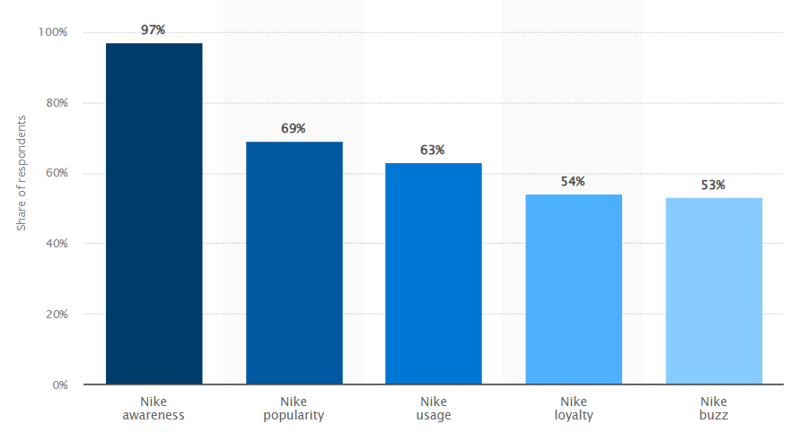

(Source: Kunst, 2024)